DeSimone_MS64060_Assignment 5

Heather DeSimone

4/9/2022

##First I have loaded in my data frame and removed the cereals that are missing information.

library(dplyr)

##   
## Attaching package: 'dplyr'

## The following objects are masked from 'package:stats':  
##   
## filter, lag

## The following objects are masked from 'package:base':  
##   
## intersect, setdiff, setequal, union

library(caret)

## Warning: package 'caret' was built under R version 4.1.2

## Loading required package: ggplot2

## Warning: package 'ggplot2' was built under R version 4.1.2

## Loading required package: lattice

library(class)  
library(ISLR)

## Warning: package 'ISLR' was built under R version 4.1.1

library(tidyverse)

## Warning: package 'tidyverse' was built under R version 4.1.3

## -- Attaching packages --------------------------------------- tidyverse 1.3.1 --

## v tibble 3.1.2 v purrr 0.3.4  
## v tidyr 1.1.4 v stringr 1.4.0  
## v readr 2.1.2 v forcats 0.5.1

## Warning: package 'tidyr' was built under R version 4.1.2

## Warning: package 'readr' was built under R version 4.1.3

## Warning: package 'stringr' was built under R version 4.1.2

## Warning: package 'forcats' was built under R version 4.1.3

## -- Conflicts ------------------------------------------ tidyverse_conflicts() --  
## x dplyr::filter() masks stats::filter()  
## x dplyr::lag() masks stats::lag()  
## x purrr::lift() masks caret::lift()

library(factoextra)

## Warning: package 'factoextra' was built under R version 4.1.3

## Welcome! Want to learn more? See two factoextra-related books at https://goo.gl/ve3WBa

library(stats)  
DF=read.csv("C:/Users/hdesi/Desktop/MBA/Machine Learning/Cereals.csv")  
DF <- na.omit(DF) ##Remove cereals missing data  
DF$mfr<-NULL ##Not needed  
DF$type<-NULL ##Not needed  
rownames(DF) <- DF$name ##Change row name to cereal name rather than numeric value  
DF$name<-NULL  
head(DF)

## calories protein fat sodium fiber carbo sugars potass  
## 100%_Bran 70 4 1 130 10.0 5.0 6 280  
## 100%_Natural_Bran 120 3 5 15 2.0 8.0 8 135  
## All-Bran 70 4 1 260 9.0 7.0 5 320  
## All-Bran_with_Extra_Fiber 50 4 0 140 14.0 8.0 0 330  
## Apple_Cinnamon_Cheerios 110 2 2 180 1.5 10.5 10 70  
## Apple_Jacks 110 2 0 125 1.0 11.0 14 30  
## vitamins shelf weight cups rating  
## 100%_Bran 25 3 1 0.33 68.40297  
## 100%_Natural_Bran 0 3 1 1.00 33.98368  
## All-Bran 25 3 1 0.33 59.42551  
## All-Bran_with_Extra_Fiber 25 3 1 0.50 93.70491  
## Apple_Cinnamon_Cheerios 25 1 1 0.75 29.50954  
## Apple_Jacks 25 2 1 1.00 33.17409

sapply(DF, class) ##Making sure variables are numerical

## calories protein fat sodium fiber carbo sugars potass   
## "integer" "integer" "integer" "integer" "numeric" "numeric" "integer" "integer"   
## vitamins shelf weight cups rating   
## "integer" "integer" "numeric" "numeric" "numeric"

##Creating data frame for normalization

DF.norm <- data.frame(DF)  
  
head(DF.norm)

## calories protein fat sodium fiber carbo sugars potass  
## 100%_Bran 70 4 1 130 10.0 5.0 6 280  
## 100%_Natural_Bran 120 3 5 15 2.0 8.0 8 135  
## All-Bran 70 4 1 260 9.0 7.0 5 320  
## All-Bran_with_Extra_Fiber 50 4 0 140 14.0 8.0 0 330  
## Apple_Cinnamon_Cheerios 110 2 2 180 1.5 10.5 10 70  
## Apple_Jacks 110 2 0 125 1.0 11.0 14 30  
## vitamins shelf weight cups rating  
## 100%_Bran 25 3 1 0.33 68.40297  
## 100%_Natural_Bran 0 3 1 1.00 33.98368  
## All-Bran 25 3 1 0.33 59.42551  
## All-Bran_with_Extra_Fiber 25 3 1 0.50 93.70491  
## Apple_Cinnamon_Cheerios 25 1 1 0.75 29.50954  
## Apple_Jacks 25 2 1 1.00 33.17409

##I will perform hierarchical clustering using Euclidean Distance

DF.norm <- scale(DF) ##Data normalization  
DF.norm.Euclidean <- dist(DF.norm, method = "euclidean")  
hc1 <- hclust(DF.norm.Euclidean, method = "complete")  
  
plot(hc1, cex = .6, hang = -1) ##Plotting the cluster Dendrogram using all variables still in dataset

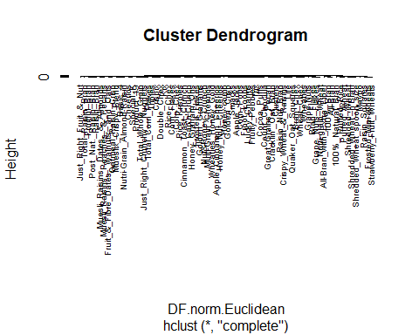

##I will now use Agnes to compare clustering methods to find the best one

library(cluster)  
hc_single <- agnes(DF.norm, method = "single")  
hc_complete <- agnes(DF.norm, method = "complete")  
hc_average <- agnes(DF.norm, method = "average")  
hc_ward <- agnes(DF.norm, method = "ward") ##Ward is the best method  
  
print(hc_single$ac)

## [1] 0.6067859

print(hc_complete$ac)

## [1] 0.8353712

print(hc_average$ac)

## [1] 0.7766075

print(hc_ward$ac) ##closest to 1

## [1] 0.9046042

##I will now create my Agnes Dendrogram

pltree(hc_ward, cex = 0.6, hang = -1, main = "Dendogram of Agnes")  
rect.hclust(hc_ward, k = 4, border = 1:4) ##4 clusters

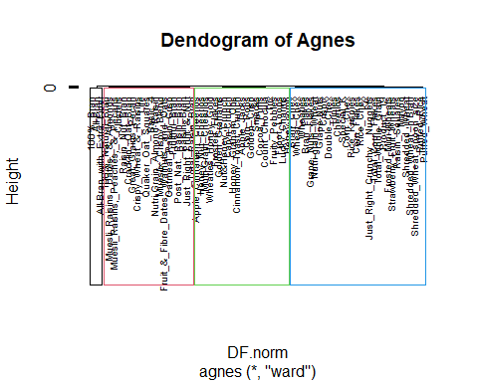

##Now I want to cluster my data by unhealthy variables. For our purposes, we will assume that cereals high in calories, fat, sugar, and sodium are unhealthy.

DF.Unhealthy <- DF[c(1,3,4,7)] ##Calories, fat, sodium, sugar  
head(DF.Unhealthy)

## calories fat sodium sugars  
## 100%_Bran 70 1 130 6  
## 100%_Natural_Bran 120 5 15 8  
## All-Bran 70 1 260 5  
## All-Bran_with_Extra_Fiber 50 0 140 0  
## Apple_Cinnamon_Cheerios 110 2 180 10  
## Apple_Jacks 110 0 125 14

##Finding best Agnes method

unhealthy_single <- agnes(DF.Unhealthy, method = "single")  
unhealthy_complete <- agnes(DF.Unhealthy, method = "complete")  
unhealthy_average <- agnes(DF.Unhealthy, method = "average")  
unhealthy_ward <- agnes(DF.Unhealthy, method = "ward") ##Best method  
  
print(unhealthy_single$ac)

## [1] 0.7794119

print(unhealthy_complete$ac)

## [1] 0.967792

print(unhealthy_average$ac)

## [1] 0.9423144

print(unhealthy_ward$ac)

## [1] 0.9868955

##Ward was the best method for clustering. Now we will create our dendograph to look at our clusters for unhealthy variables.

pltree(unhealthy_ward, cex = 0.6, hang = -1, main = "Dendograph Using Unhealthy Variables:Fat, Calories, Sugar & Sodium")  
rect.hclust(unhealthy_ward, k = 4, border = 1:4)

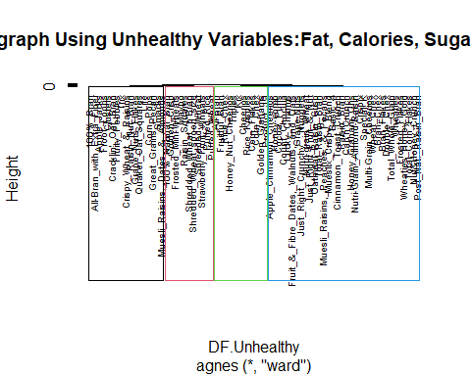

##So far, it looks like the healthiest cluster is cluster 1(black) and the least healthy is cluster 4 (blue)

##Now we will cluster based on healthy variables. Those high in protein, fiber, and vitamins are most healthy.

DF.Healthy <- DF[c(2,5,9)] ##Protein, fiber, vitamins  
head(DF.Healthy)

## protein fiber vitamins  
## 100%_Bran 4 10.0 25  
## 100%_Natural_Bran 3 2.0 0  
## All-Bran 4 9.0 25  
## All-Bran_with_Extra_Fiber 4 14.0 25  
## Apple_Cinnamon_Cheerios 2 1.5 25  
## Apple_Jacks 2 1.0 25

##Finding best Agnes method

healthy_single <- agnes(DF.Healthy, method = "single")  
healthy_complete <- agnes(DF.Healthy, method = "complete")  
healthy_average <- agnes(DF.Healthy, method = "average")  
healthy_ward <- agnes(DF.Healthy, method = "ward")##Best method  
  
print(healthy_single$ac)

## [1] 0.9950214

print(healthy_complete$ac)

## [1] 0.9957495

print(healthy_average$ac)

## [1] 0.9948298

print(healthy_ward$ac)

## [1] 0.9983455

##Ward was the best method for clustering. Now we will create our dendograph to look at our clusters for healthy variables.

pltree(healthy_ward, cex = 0.6, hang = -1, main = "Dendograph Using Healthy Variables:Protein, Fiber & Vitamins")  
rect.hclust(healthy_ward, k = 4, border = 1:4)

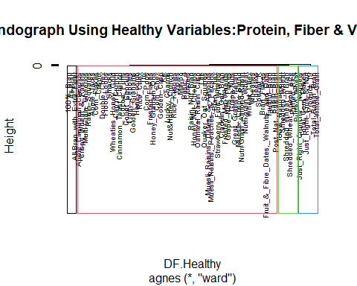

##Clustering is a bit uneven, but it looks like cluster 1 (Black) is the healthiest and there are repeat cereals in this healthy cluster that were also in the healthy cluster is our last dendograph

##Now we will look at all of our health related variables together. Our cluster will consist of protein, fiber, vitamins, calories, fat, sugar, and sodium

DF.TotalHealth <- DF[c(1,2,3,4,5,7,9)]  
head(DF.TotalHealth)

## calories protein fat sodium fiber sugars vitamins  
## 100%_Bran 70 4 1 130 10.0 6 25  
## 100%_Natural_Bran 120 3 5 15 2.0 8 0  
## All-Bran 70 4 1 260 9.0 5 25  
## All-Bran_with_Extra_Fiber 50 4 0 140 14.0 0 25  
## Apple_Cinnamon_Cheerios 110 2 2 180 1.5 10 25  
## Apple_Jacks 110 2 0 125 1.0 14 25

##Finding best Agnes

TotalHealth_single <- agnes(DF.TotalHealth, method = "single")  
TotalHealth_complete <- agnes(DF.TotalHealth, method = "complete")  
TotalHealth_average <- agnes(DF.TotalHealth, method = "average")  
TotalHealth_ward <- agnes(DF.TotalHealth, method = "ward") ##Best Method  
  
print(TotalHealth_single$ac)

## [1] 0.8615331

print(TotalHealth_complete$ac)

## [1] 0.9604174

print(TotalHealth_average$ac)

## [1] 0.9306789

print(TotalHealth_ward$ac)

## [1] 0.9837845

##Ward is again the best method. Now we will look at our dendograph in which we clustered based on all health variables (good and bad)

pltree(TotalHealth_ward, cex = 0.6, hang = -1, main = "Dendograph:Fat, Cals, Sugars, Sodium, Protein, Fiber & Vitamins")  
rect.hclust(TotalHealth_ward, k = 4, border = 1:4)

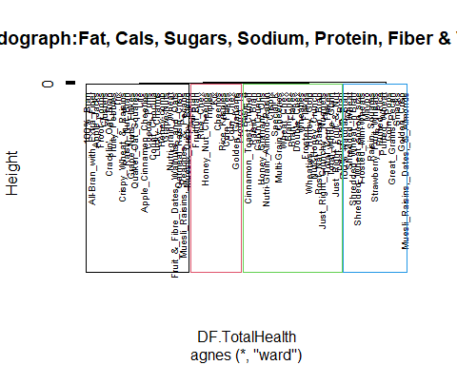

##This dendograph looks very similar to the 1st one we did (With unhealthy variables) ##Cluster 1 (black) looks to be the overall healthiest cereals

##I want to create more than 4 cluster using this same overall health model

pltree(TotalHealth_ward, cex = 0.6, hang = -1, main = "Dendograph:Fat, Cals, Sugars, Sodium, Protein, Fiber & Vitamins")  
rect.hclust(TotalHealth_ward, k = 8, border = 1:4) ##8 clusters

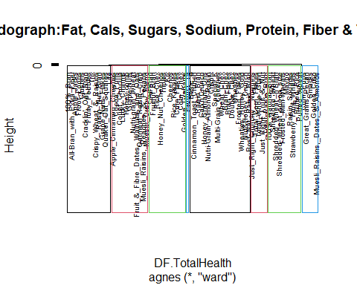

##This 8 cluster model gives us a much more condensed list. With 100% bran in all of our dendograph healthy clusters, we will assume that the cluster this cereal falls into is the healthiest group - based on sugar, fat, calories, sodium, protein, fiber, and vitamins. The school could use any of these dendographs to base their decision on, depending on what they are looking for and what they consider healthy. Some people feel that a diet low in calories, fat, sugar, and sodium is healthy even if those foods are low in nutrients. Some people feel that a diet high in vitamins, fiber, and protein are healthy even if they have higher calories, fat, sugar. and sodium. I believe that the last dendograph should be used (8 clusters) as it takes all of these variables into consideration.